Nancy’s Knit Knacks LLC
_______________________________________________________

Anything but Lazy Kate™
Assembly Instructions and User Manual
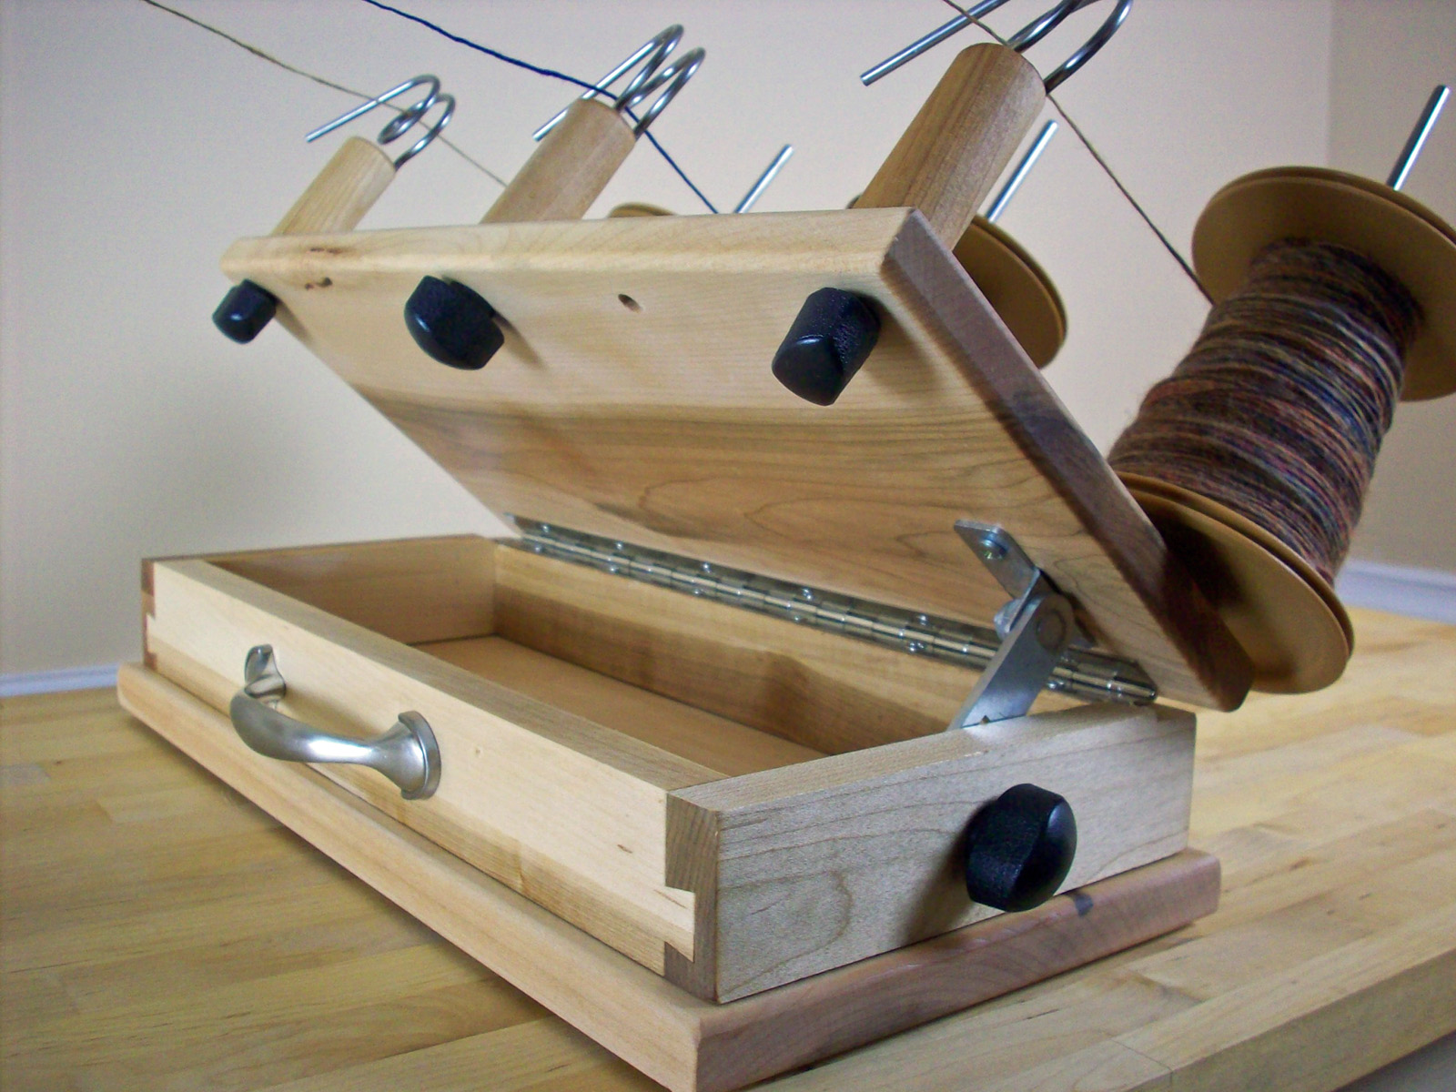
Thank you for purchasing our new Anything but Lazy Kate™ (“ABLK”). It is a full featured Kate which can handle every type of yarn as well as most bobbins and cones.
Tools Needed: None!

Assembly Instructions
The only items that need to be assembled are the 3 yarn guide posts and mating knobs, inserting the 3 bobbin rods, and inserting the Tension Post and cord (if needed). Everything else is already assembled. Just insert the posts through the holes in the top and attach the knobs. Then poke the 3 rods into the white inserts in the top.
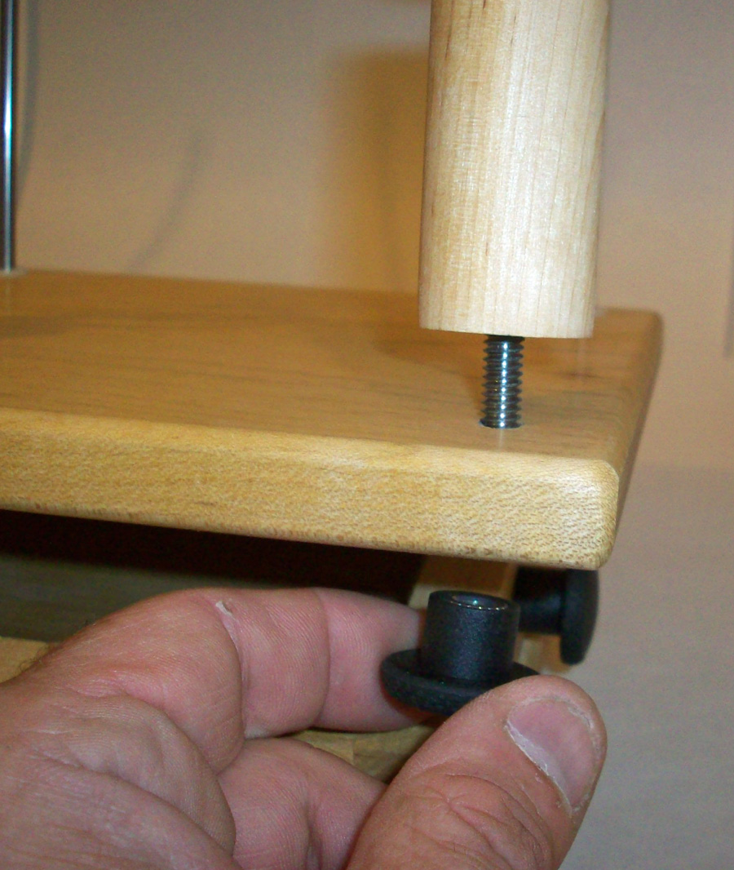
Tensioning Systems within the ABLK: The ABLK employs three different tensioning systems:
- Tilt-back top (uses gravity pulling on the bobbins to add tension to the yarn as it is being unwound from the bobbin). This unique design allows the user to alter the angle of the top and adjust the level of tension on the yarn. The greater the tilt angle, the greater the tension. Best method for art yarns.
- 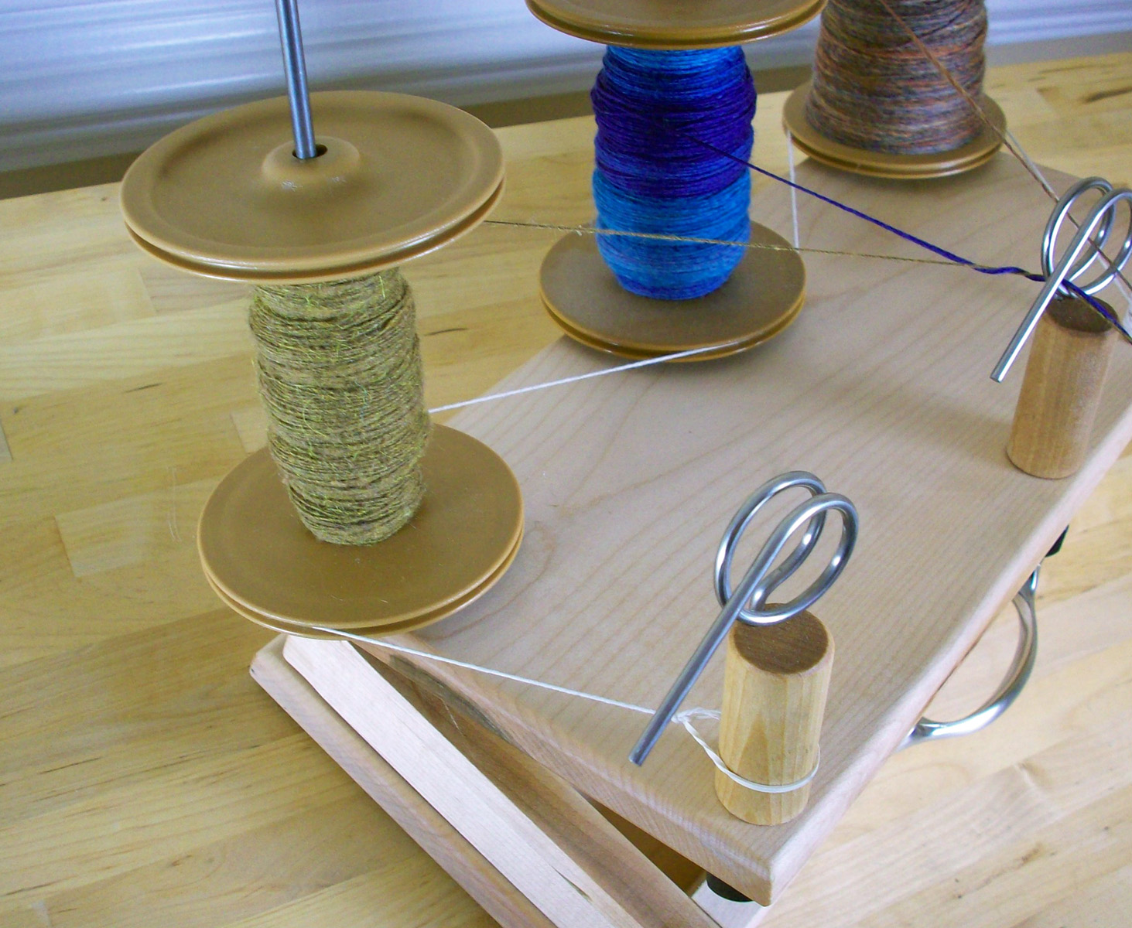Adjustable Yarn Guide Posts – the posts can be turned to exert tension on the yarn as it passes through the eyelets. The other 2 tensioning methods act on all 3 bobbins simultaneously. This tensioning method, however, allows the user to customize the tension on each bobbin individually. The long extension on the eyelet should always be turned away from the bobbin to prevent snags.
- 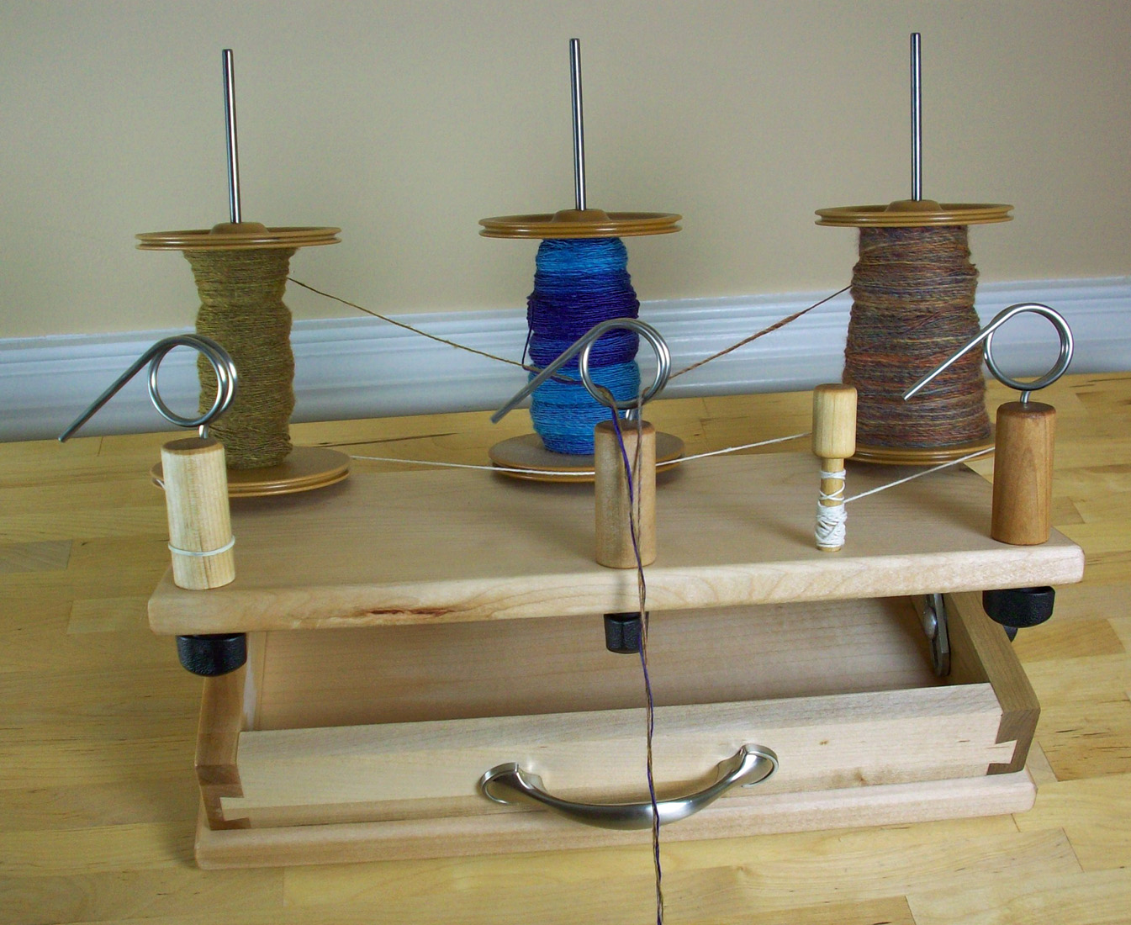Tension Post and cord – this is the standard method for applying tension to bobbins by running a cord from the tensioning post around the grooves in the bottoms of the bobbins and then attaching the end with the rubber band around the far left Yarn Guide Post. By turning the post and increasing the tautness of the cord, the user exerts more tension on the bobbins to prevent backspin. Notice in the image above how the cord goes around the front of the center bobbin to increase cord contact on that bobbin.
Features
- Knobs – all four knobs are the same. Please keep the three post knobs inserted on the posts during storage/transport to prevent them from rattling and to prevent loss.
- Adjustable Top – feel free to adjust the angle of the top. It can be adjusted from 0 to 45 degrees. The steeper that the angle is, the greater the tension will be on the yarn. Do this for cones of yarn, also.
- Tensioning post cord – The cord used on the tensioning post is “cotton carpet warp.” Any non-stretchy cord will work if the cord ever needs to be replaced. The rubber band must stretch to work properly.
- 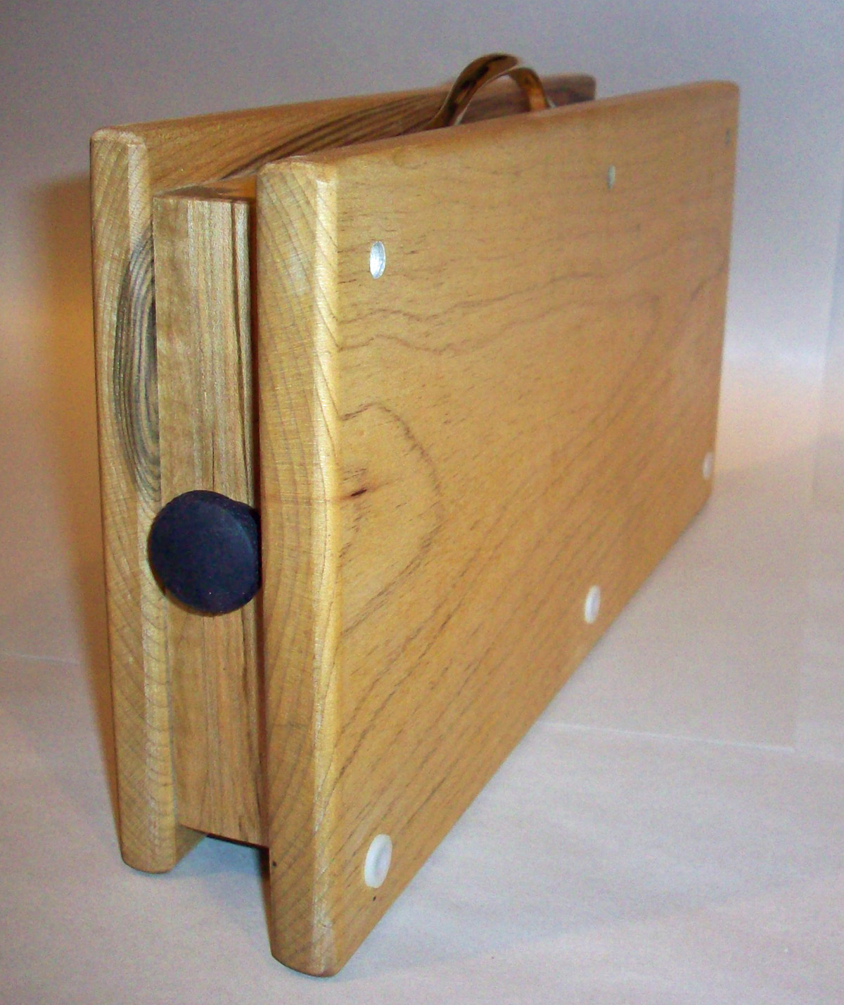Before transporting the Kate – Put the rods inside the paper Tube. Attach the knobs to the yarn guide posts. Wrap the cord around the tensioning post. Place all of these items, plus any other items that you wish, inside the unit and close the lid. Be sure to tighten the knob. The carry handle allows you to easily carry the unit.
- Finish of the wood – the Maple hardwood has been treated with a wood stain. Any odor it has will dissipate over time,
- No parts need to be oiled.
- If the handle starts to come loose for any reason, re-tighten the screws inside the Kate.
- Optional Cone support accessories – Cone Accessory Kits are available which contain everything you need to mount a single 7” cone of yarn on the ABLK. Each kit includes: 2 wooden discs (2” & 2.375” dia.), two steel washers, an Allen wrench, and 3 shaft collars. These components are mounted on one of the rods included with the ABLK (2 wood discs are provided to fit into different size cones but you only mount 1 at a time). The steel washers can be mounted on the top of cone. The yarn on the cone can be tensioned by tilting the top back or adjusting the yarn guide angle. The ABLK then transforms itself into a great cone holder! We also offer optional, longer 11” rods if you have 10” tall cones.

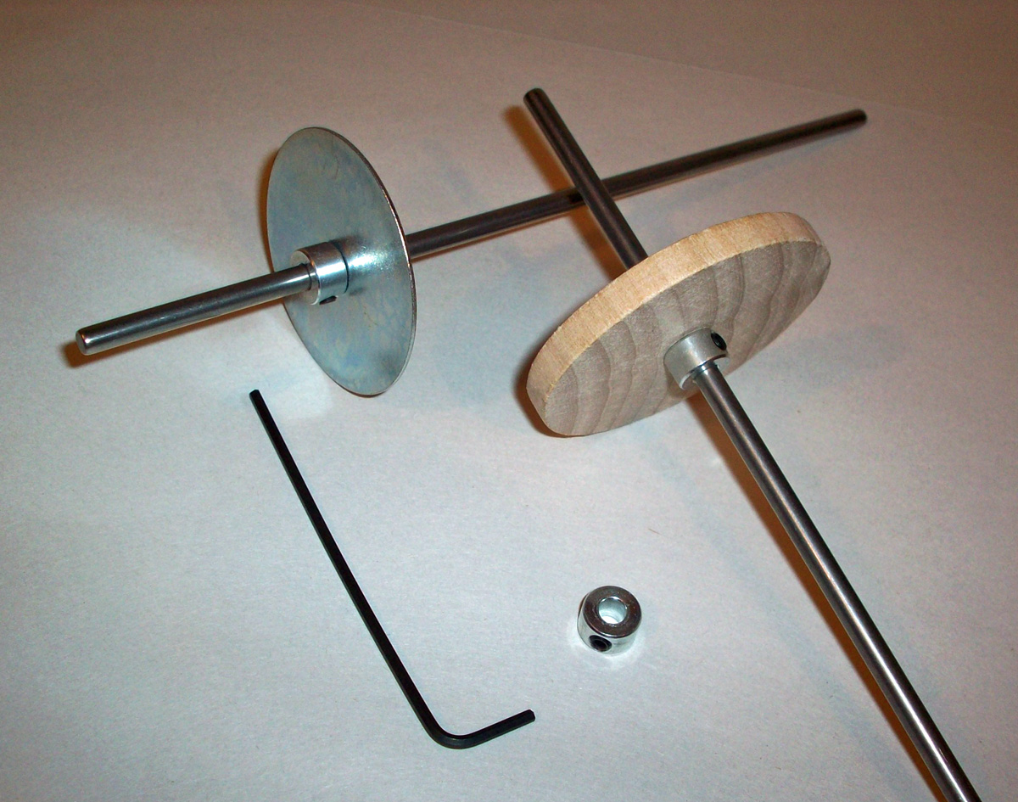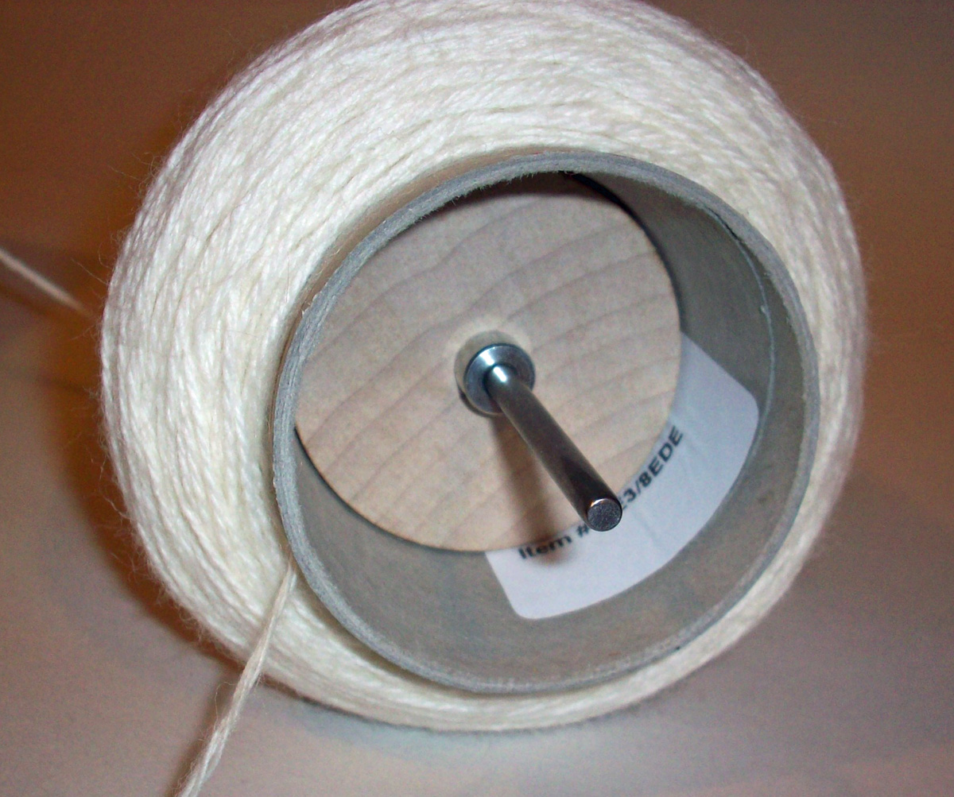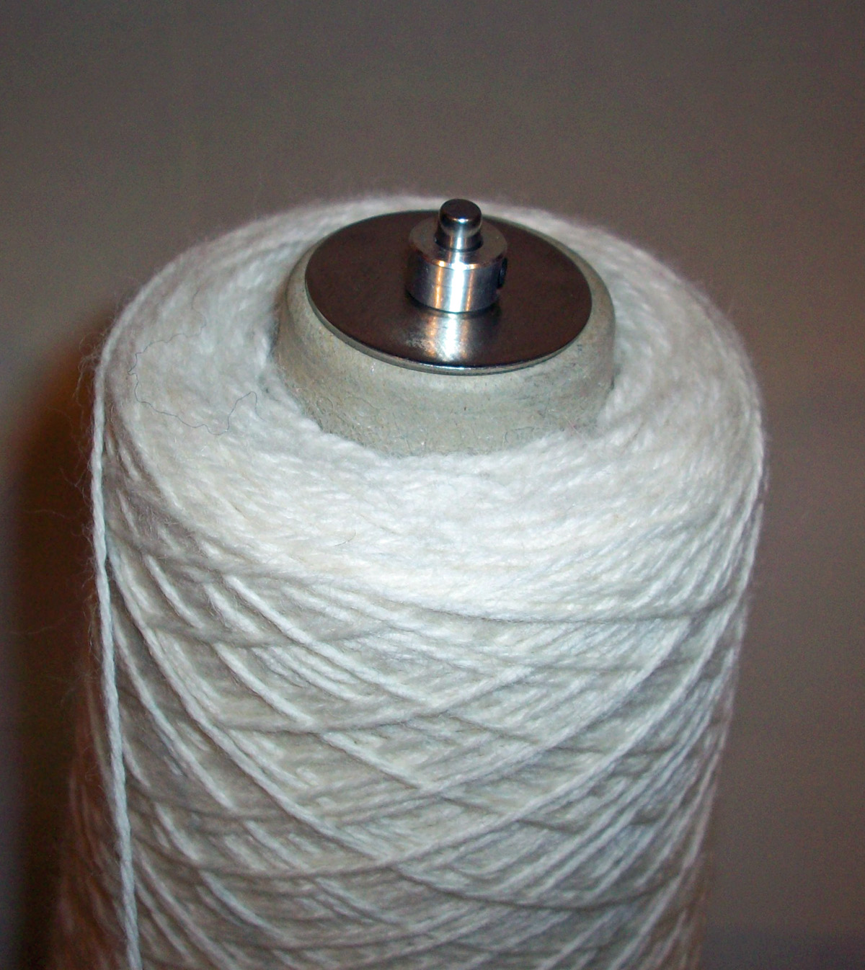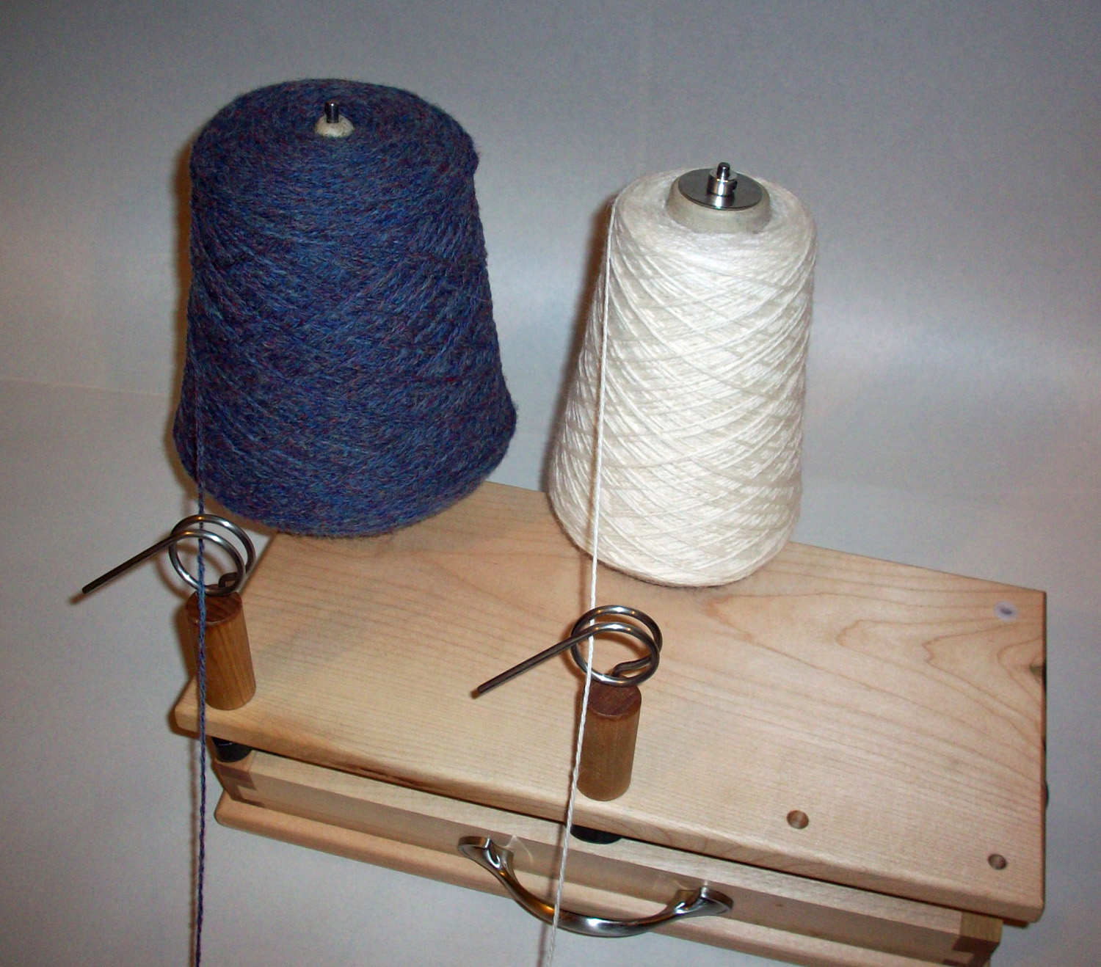

Note: Please make sure you experiment with tension when adjusting the yarn guide post angles. You increase tension on the yarn by loosening the knob and turning the post so that the eyelet forces the yarn passing through it to “bend” slightly. It is this bending action on the yarn that increases the tension. Often times, adding tension to the yarn will solve many other issues/problems. The lack of tension can lead to other issues. So learn how the ABLK can maximize your use of tension by experimenting with all three forms of tension control.

Sometimes you will direct the yarn from all three bobbins through the center yarn guide post. Other times, you may want to have each bobbin feed yarn through its own yarn guide post. Once again, experiment and determine which method is right for you and for the type of yarn that you are using.
We also offer a special anti-tip bracket for users of the Ashford Country Spinner or other large bobbin wheels.

Be sure to check out our website at www.nancysknitknacks.com. We have many other World-class products for spinners and knitters. We may also add new options for the ABLK!

In the meantime, we hope that you enjoy using the ABLK for many years to come. It is a professional grade tool. Thank you for supporting American ingenuity and workmanship.

